Report

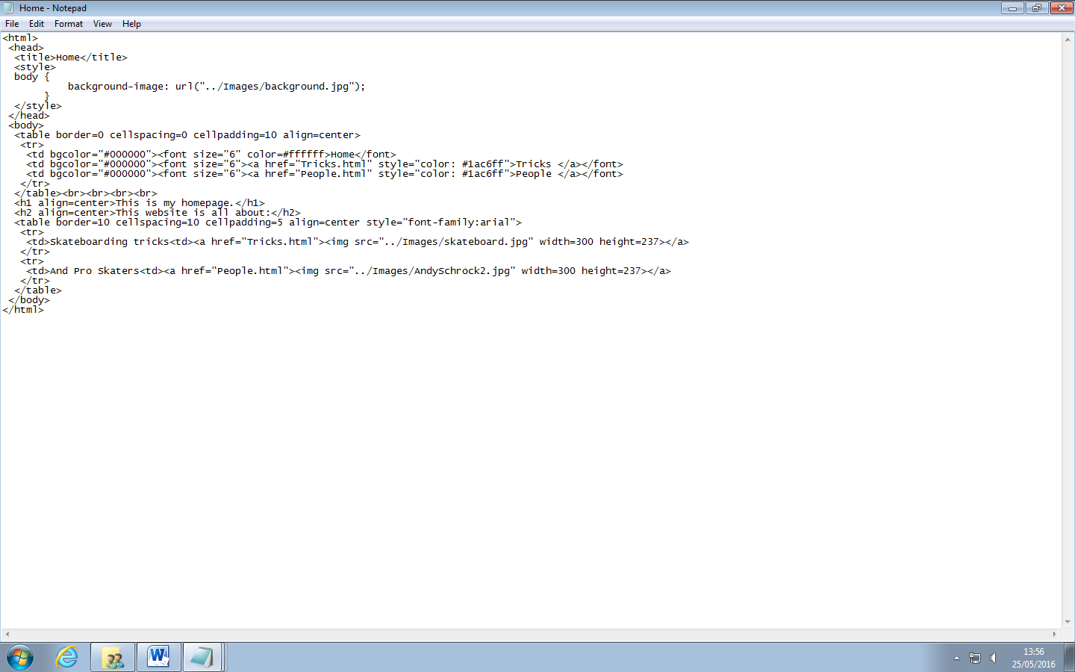

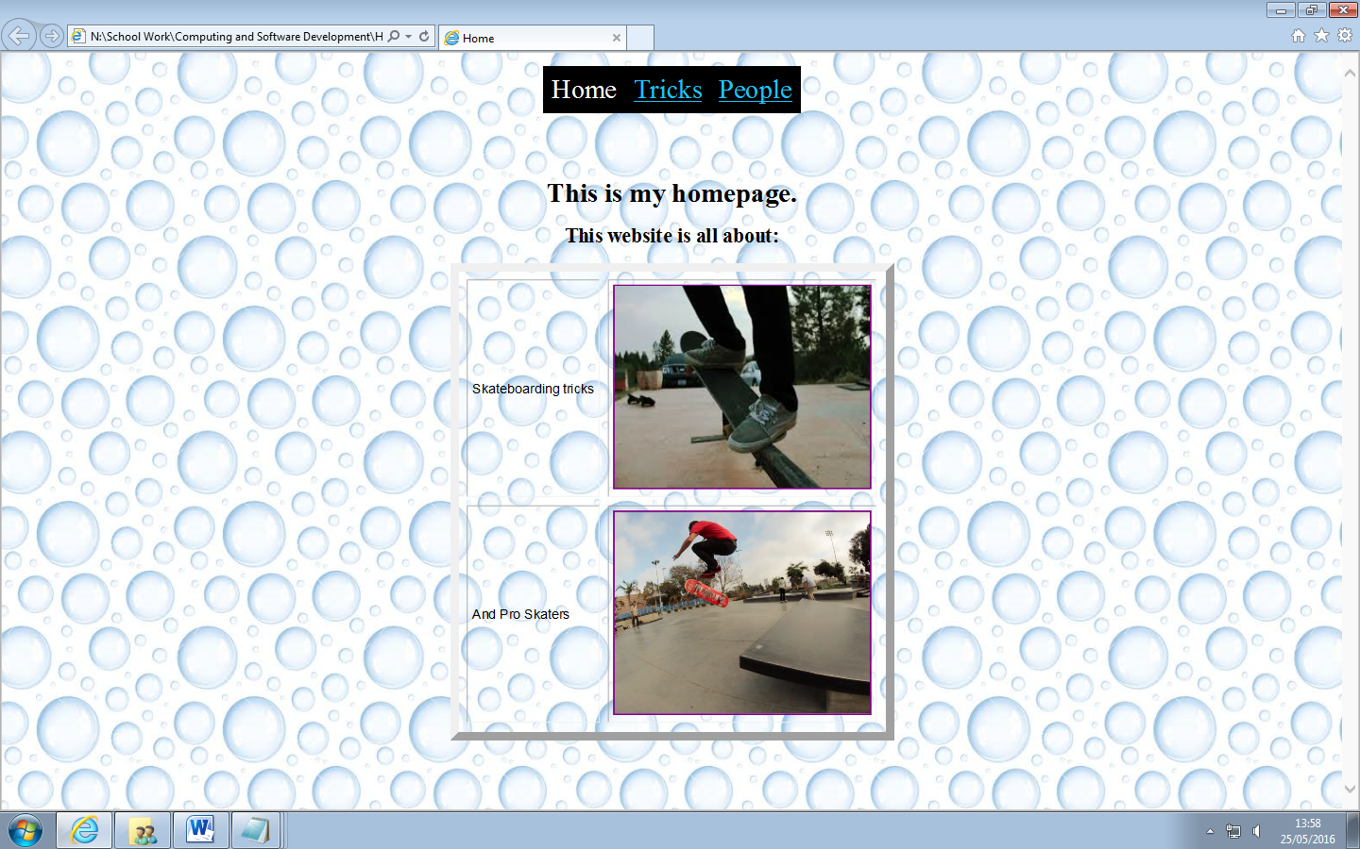

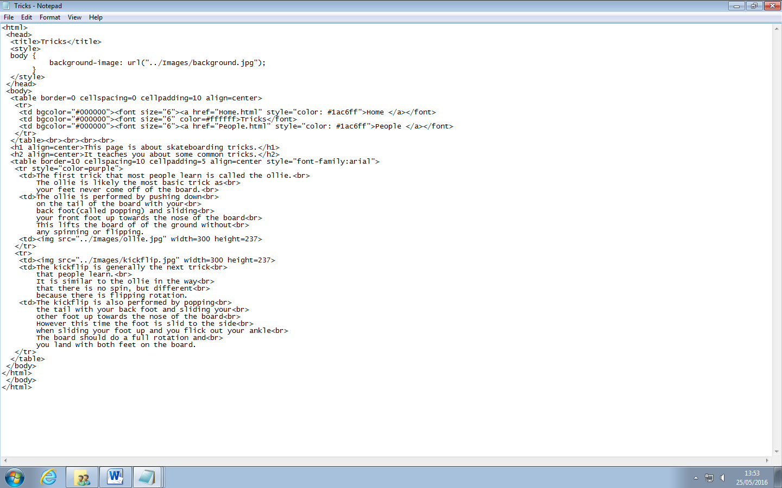

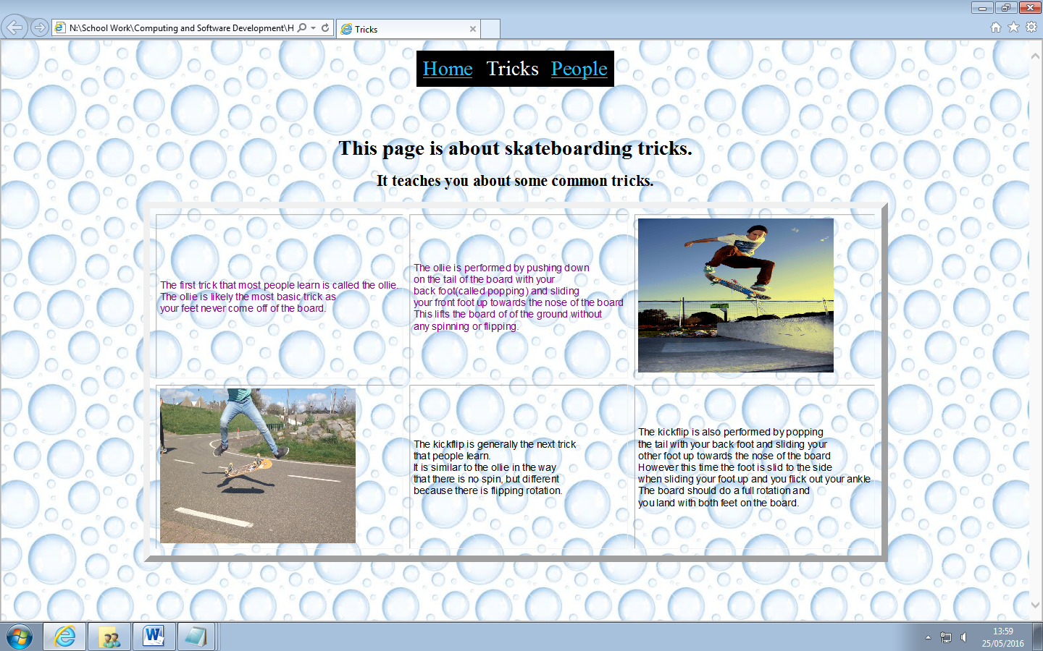

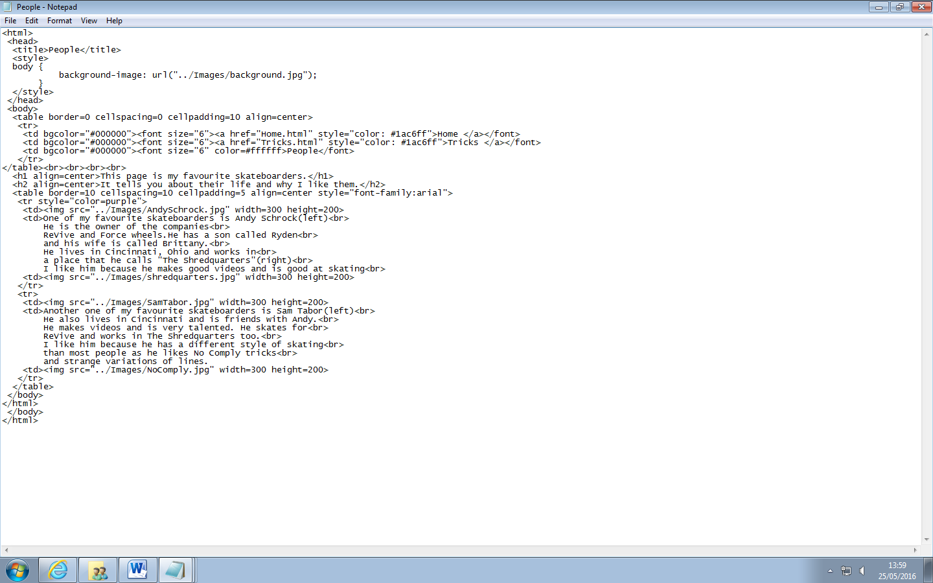

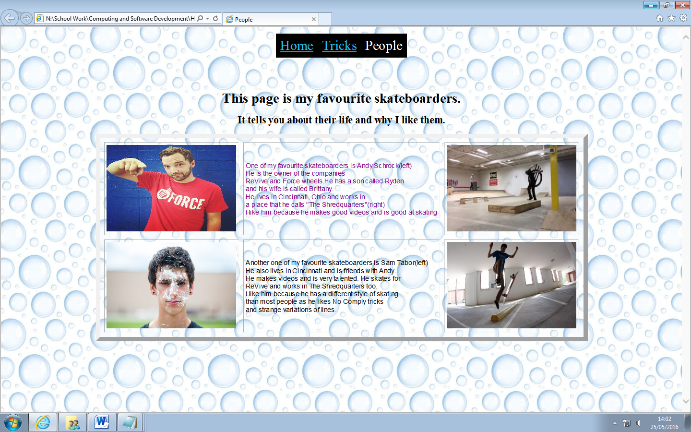

I like the look of my website because it is easy to see where you are and navigate where you want to go. My webpages all contain information on what they should be about and they’re all of a similar layout. They use the same background image and the same fonts and colours. The graphics used were all copyright free and related to the text. As far as I can see, my punctuation and spelling is correct. I think I could’ve used a variety of styles of text sizes, fonts and colours.